**Module - 3 (Fuzzy Logic & Defuzzification)**

* Fuzzy sets – properties, operations on fuzzy set. Fuzzy membership functions,
* Methods of membership value assignments – intuition, inference, Rank Ordering.
* Fuzzy relations– operations on fuzzy relation. Fuzzy Propositions. Fuzzy implications.
* Defuzzification– Lamda cuts, Defuzzification methods.

5 Using your own intuition, plot the Fuzzy membership function for the “Age of people”. (3)

6 Let A={(x1,0.5), (x2,0.1), (x3,0.9)} and B={(x1,0.4), (x2,0.4), (x3,0.5)} Find intersection, union and complement of both the fuzzy sets. (3)

5 Using your intuition and definition of the universe of discourse, plot membership functions for temperature in a room. Define the fuzzy sets as cold, cool, warm, hot, and very hot. (3)

6 Let A={(x1,0.7), (x2,0.3), (x3,0.9)}and B={(x1,0.6), (x2,0.4), (x3,0.8)}. Find intersection, union and complement of both the fuzzy sets (3)

5 Using your own intuition, plot the Fuzzy membership function for the “Age of people”? (3)

6 What are the three basic features involved in characterizing a fuzzy membership function? Explain. (3)



5 With the help of a figure, explain the features of fuzzy membership functions. (3)

6 State the relevance of fuzzification. (3)

**Fuzzification** is the process of converting **crisp input values** (precise numerical data) into **fuzzy sets** using **membership functions**.

**✅ Relevance of Fuzzification:**

1. **Handles Uncertainty and Vagueness**:  
   It allows systems to work with **imprecise or linguistic information** like "high temperature" or "low speed".
2. **Enables Fuzzy Inference**:  
   It’s essential for applying **fuzzy logic rules** in decision-making systems (e.g., "IF temperature is high THEN fan speed is fast").
3. **Bridges Real World with Fuzzy Logic Systems**:  
   Translates real-world sensor inputs into a format that **fuzzy logic controllers** can process.

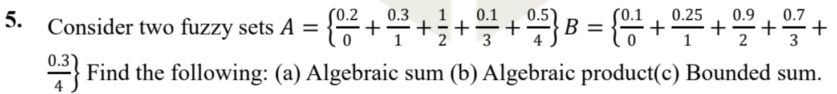

6. Using your own intuition and definition of universe of discourse, plot membership

#### ✅ ****Universe of Discourse****

It is the **range of all possible input values** for a variable in a fuzzy system.

Example: For the fuzzy variable **"temperature"**, the universe of discourse might be:

### ✅ **Membership Function**

A membership function maps each value in the universe of discourse to a **degree of membership** between 0 and 1.

For instance, the fuzzy set **"Warm"** could be defined by how much a temperature belongs to the "Warm" category.

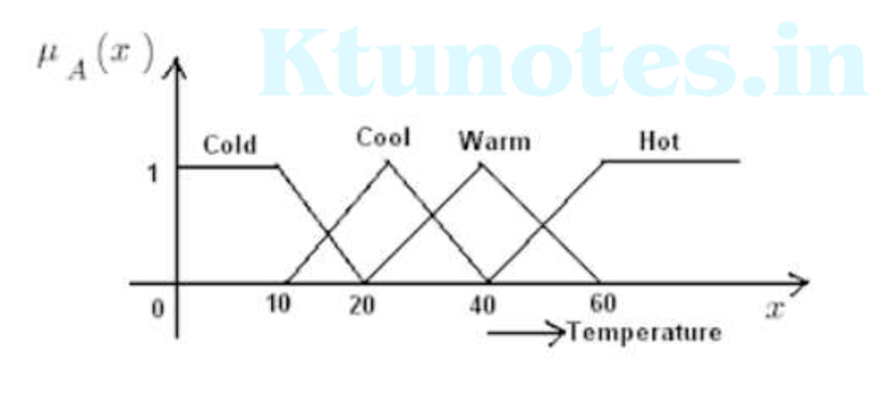

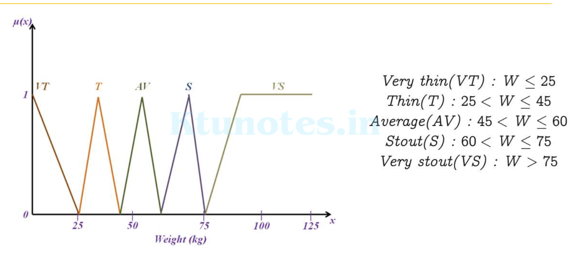

15. (a) Three fuzzy sets are defined as follows:

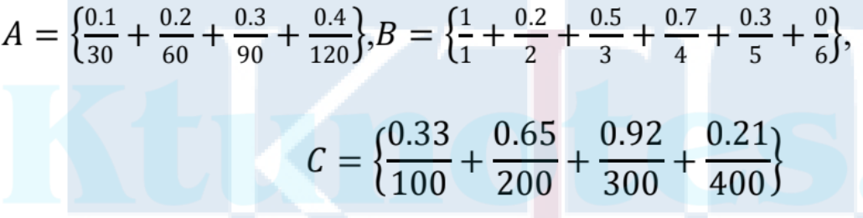

Find: (i)R = A × B (ii) S= B × C (iii)T = RoS , using Max-Min composition (iv)T = RoS , using Max-Product composition. (10)

(b) For the fuzzy sets given Find relation R by performing Cartesian product over the given fuzzy sets. (4)

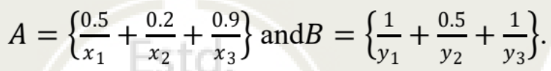

16. (a) Using inference approach, find the membership values for each of the triangular shapes (I, R, IR, T) for a triangle with angles 120°, 50°, 10°. (8)

(b) Using Zadeh’s notation, determine the ʎ - cut sets for the given fuzzy sets: (6)

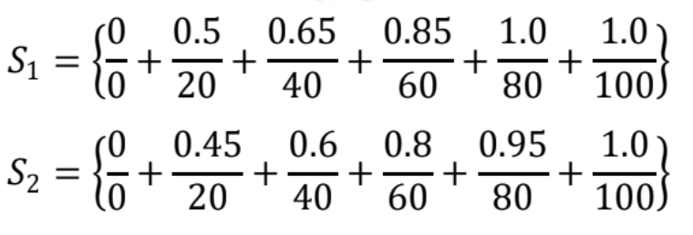

Express the following for ʎ = 0.5: a) S1 ∪ S2 b) S2 ́ c) S1 ∩ ́ S2

15 a) Using inference method, find the membership values of the triangular shapes; isosceles (I), right angled (R), isosceles and right angled (IR), equilateral (E), and other triangles(T); for a triangle with angles 120°, 50°, 10°. (8)

b) Consider the following two fuzzy sets:

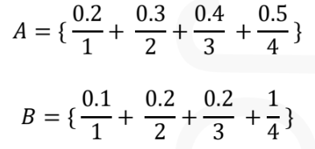

Find the algebraic sum, algebraic product, bounded sum, and bounded difference for the given sets. (6)

16 a) Three fuzzy sets are defined as follows:

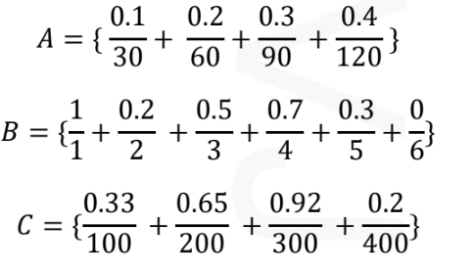

Find: (i)R = A × B (ii) S = B × C (iii) T = RoS, using Max-Min composition (iv)T = RoS, using Max-Product composition.

b) What is defuzzification? Explain any four defuzzification methods. (6)

15 a) Given two fuzzy sets A and B, compute the following set operations on A and B:

a) Algebraic sum b) Algebraic product c) Bounded sum d) Bounded difference (6)

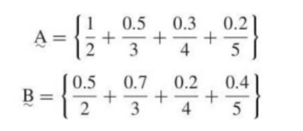

b) What is defuzzification? Explain different defuzzification methods with examples. (8)

16 a) Consider the fuzzy relation

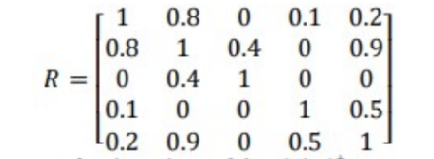

Perform λ-cut operations for the values of λ = 0.9, 0+? (5)

b) Let A be a fuzzy set that tells about a student as shown in figure below. Here, the linguistic variable P represents a Pass student, F stands for a Fair student, G represents a Good student and VG represents a Very Good student. Calculate the defuzzified value for the fuzzy set A with weighted average method and center of sums. (9)



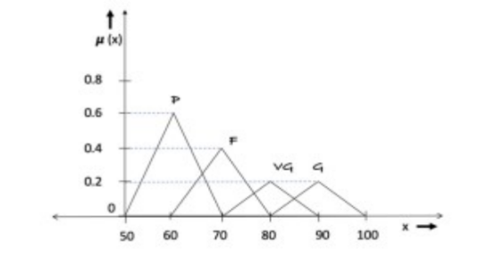

15 a) Using intuition and your own definition of the universe of discourse, plot fuzzy membership functions to the following variables: Liquid level in the tank

(a)Very small (b) Small (c) Empty (d) Full (e) Very full 5

b) Define defuzzification. With the help of examples, explain various defuzzification methods. 9

15 a) Consider the following two fuzzy sets: A = {0.2/1,0.3/2,0.4/3,0.5/4} and B = {0.1/1,0.2/2,0.2/3,1/4}. Find the algebraic sum, algebraic product, bounded sum, and bounded difference for the given sets. (10)

b) Represent the standard fuzzy set operations using the Venn diagram. (4)

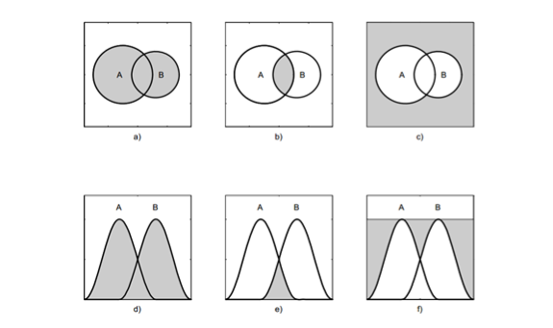

16 a) Three fuzzy sets are defined as follows: (10)

A={(0.2/20),(0.3/50),(0.5/80),(0.7/110)}

B={(0.8/1),(0.5/2),(0.6/3),(0.4/4),(0.2/5),(0.1/6)}and

C={(0.4/100),(0.7/200),(0.9/300),(0.3/400)}

Find: (i)R = A × B (ii) S = B × C (iii) T = RoS, using Max-Min composition (iv)T = RoS, using Max-Product composition.

b) State the conditions for fuzzy tolerance and fuzzy equivalence relations. (4)



16 a) Consider the discrete fuzzy set defined on the universe X= {a, b, c, d, e} as

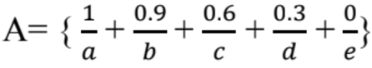, Using Zadeh’s notation, find the λ- cut sets for λ = 1,0.9, 0.6, 0+ and 0. (5)

b) Given two universes X= {x1, x2, x3, x4, x5} and Y= {y1, y2, y3, y4, y5}, the fuzzy sets A defined on X and fuzzy set B defined on Y are given below.

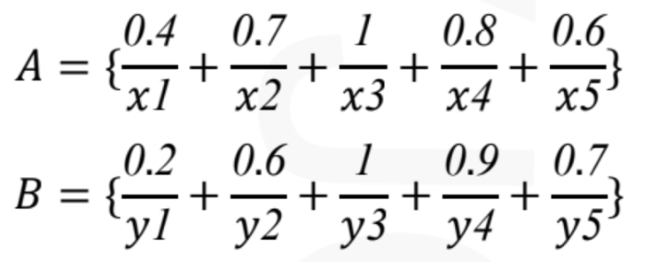

i) Find the relation R = A × B Consider another fuzzy set C defined on the universe V = {v1, v2, v3}

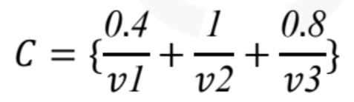

ii) Find P = B × C.

iii) Using max-min composition find RoP.

1. There is an imprecise relationship between the ambient temperature for clay masonry bricks and their compressive strengths. Let X be a fuzzy set of fracture strengths and Y be a fuzzy set of temperatures with the following membership functions:

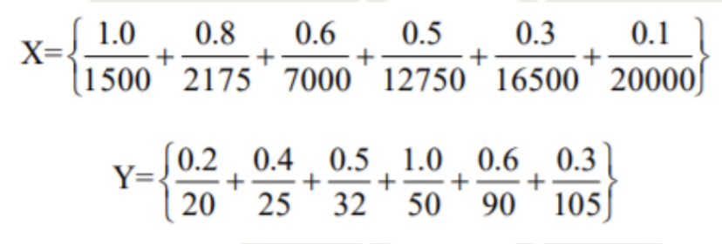

(a) Find the Cartesian Product of X and Y and represent it as relation R. Suppose there is a second fuzzy set of masonry lengths given as

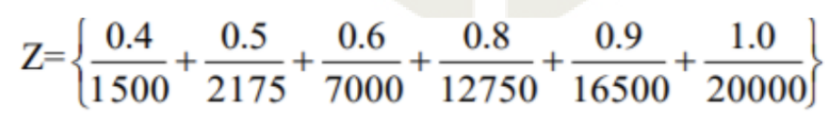

(b) Find S=ZoR using max-min composition (c) Find T=ZoR using max-product composition

2. Given two universes X={x1,x2,x3,x4,x5} and Y={y1,y2,y3,y4,y5},the fuzzy sets A defined on X and fuzzy set B defined on Y are given below:

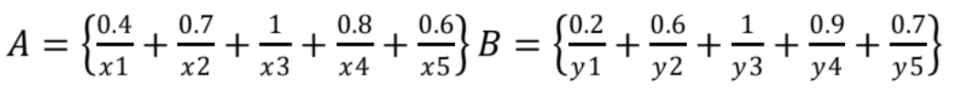

(i)Find the relation R = A × B

Consider another fuzzy set C defined on the universe V={v1,v2,v3}, 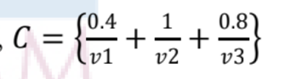

(ii) Find P = B × C. Using max-min composition, Find RoP.